|  |  |
| --- | --- |
| Date: | 28 October 2022 |
| Team ID: | PNT2022TMID42671 |
| Project Name: | IOT BASED CROP PROTECTION SYSTEM FOR AGRICULTURE |

  **IOT BASED CROP PROTECTION SYSTEM FOR AGRICULTURE**

TEMPERATURE SENSOR

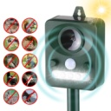 

ULTRASONIC ELECTRONIC REPELLENT CELLULAR TOWER

IMG_20221030_204926.jpg 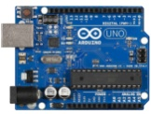 GATEWAY.jpg   WATER AND MOISTURE LEVEL SENSOR ARDUINO MICRO CONTROLER GATEWAY MODULE ROUTER INTERNET CLOUD

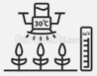

SPRINKLER

 

**NOW I CAN MONITOR FARM AT ANYTIME AND ANYWHERE**

MOTOR PUMP

